

One of the most important ideas in deep learning has been batch normalization. Batch normalization makes the hyperparameter search much more easier and makes the network much more robust to the choice of hyperparameters that work well.

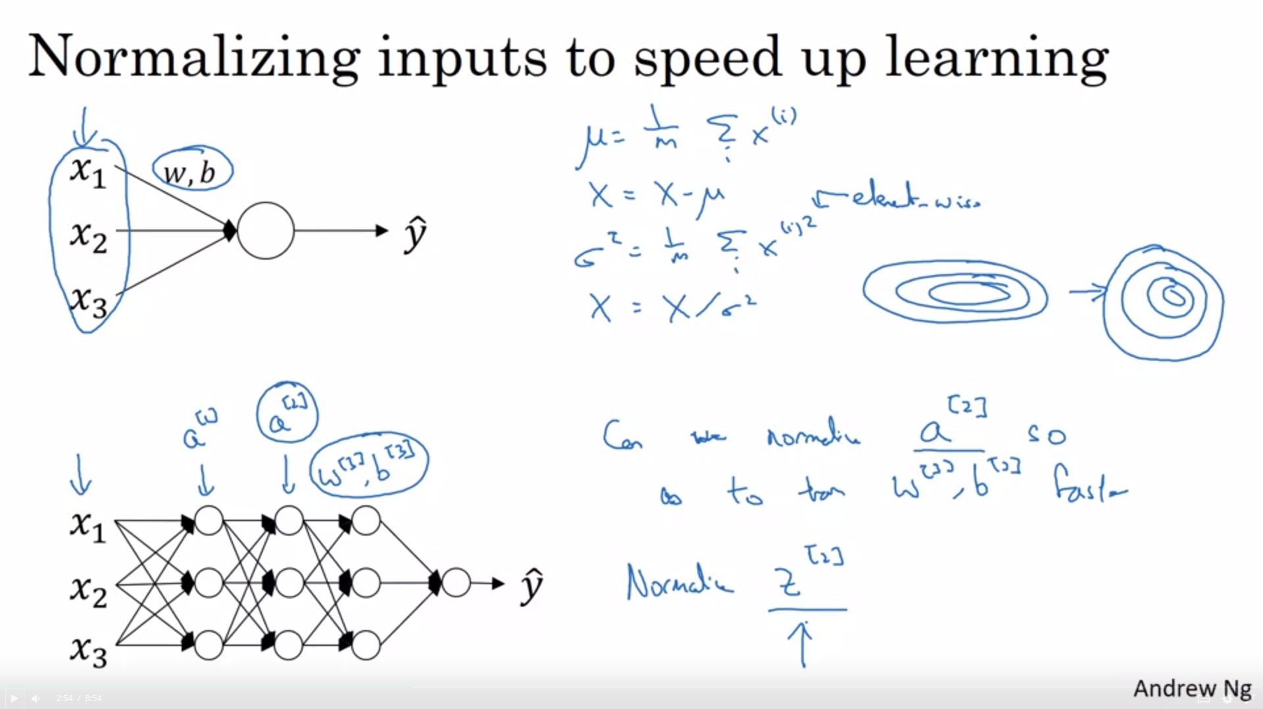

Remember that normalizing the input features can speed up training -> elongated shape becomes round shape.

In a deeper model it would be nice to normalize in between the layers. This is what batch norm does. Technically we normalize the values of z[2] and not a[2]. There is some debate between researchers. Most people normalize z[2].

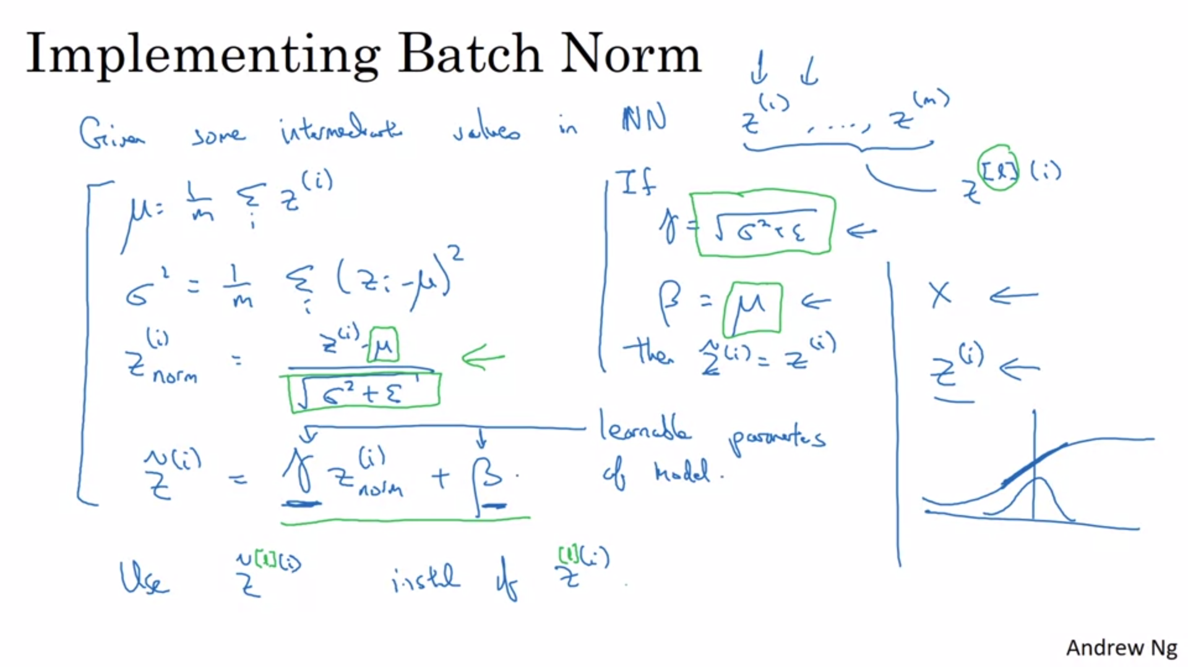

We omit the [l] on this slide.

Subtract mean and divide by standard distribution. We add epsilon for numerical stability.

We don’t want the hidden units to always have mean 0 and sd 1. Maybe it makes sense that they have a different distribution. We introduce two learnable parameters gamma and beta.

The effect of gamma and beta is that it allows to set the mean to whatever the network wants it to be. The network can also learn the identity function here.

Summary: batch norm -> apply normalization to hidden unit values Z in the network but do not force them to have mean 0 and sd 1 (but it ensures standardized mean and sd).



How does batch norm fit in to the training of a deep network?

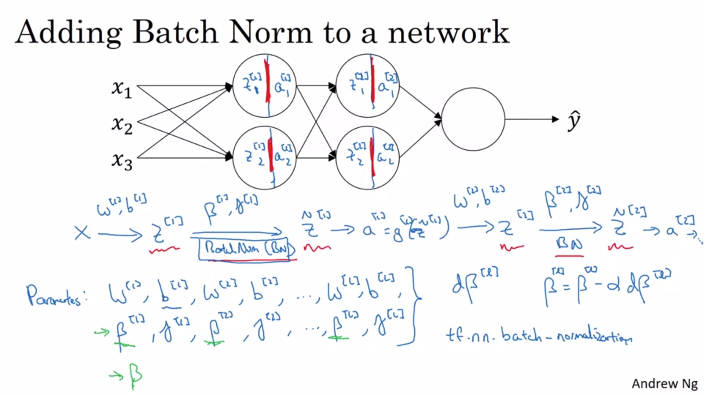

View each hidden unit as computing two things: z and a.

Batch norm step is in between the computation of z and a.

We have added betas and gammas for each layer as parameters.

Deep learning frameworks have implementations for batch norm, so you just need one line of code.

Batch norm is usually applied together with mini batches.

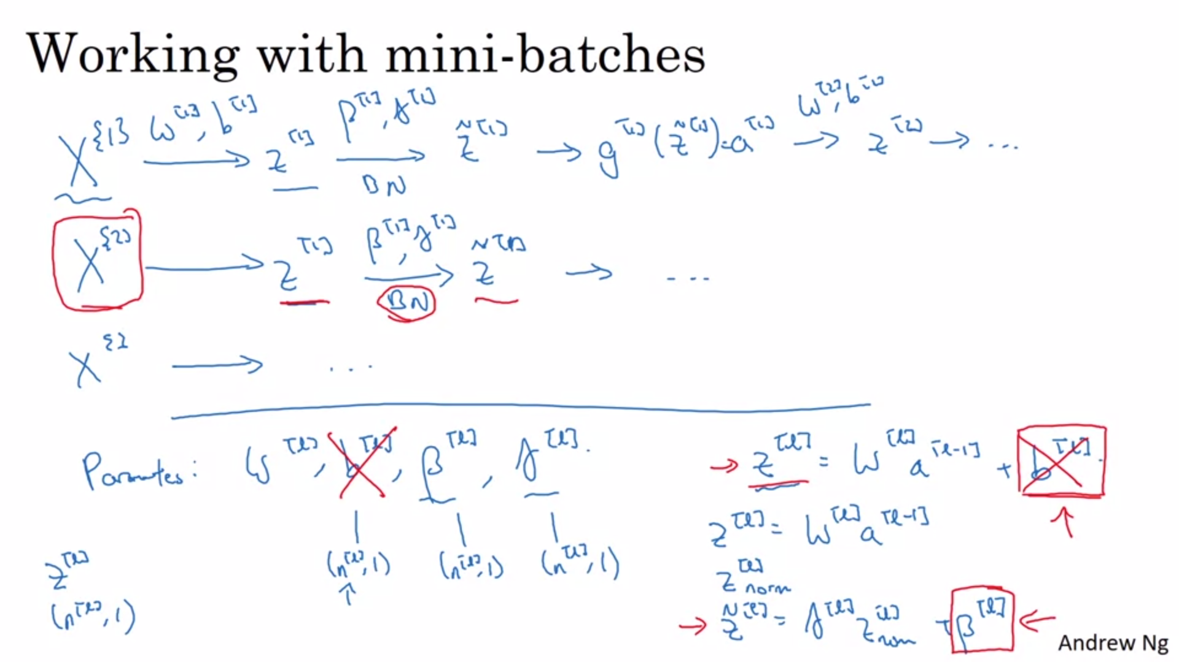

Compute the mean and variance of just this mini batch.

Adding the constant b does not change anything because it is normalized out. So we can eliminate the b parameter. It is sort of replaced by beta.

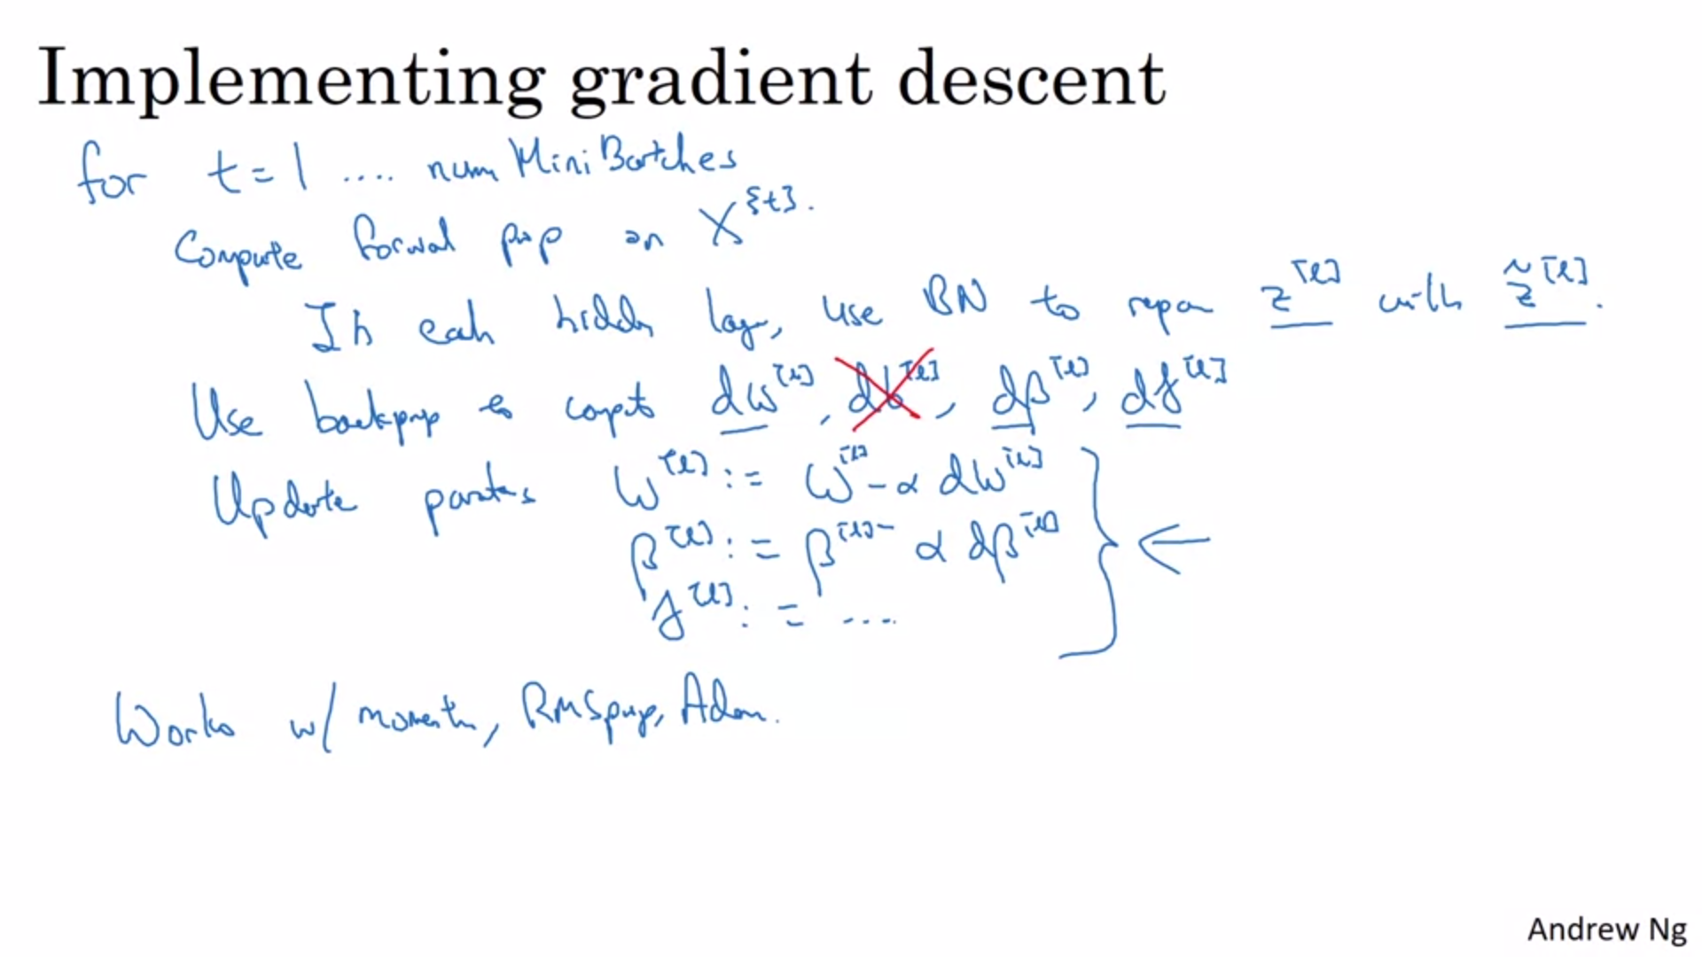

We have already seen how normalizing the input features can speed up learning. Batchnorm is doing a similar thing but for the hidden layers.

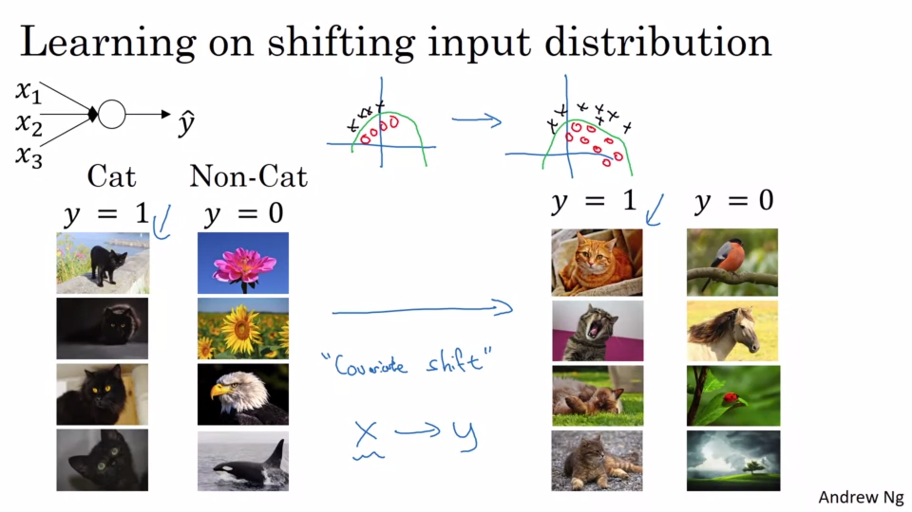

Example: shallow network to detect cats. Trained on black cats. Now applied to colored cats. Classifier might not do well to discover the decision boundary needed for the right data given the data on the left.

If the distribution of X changes you might need to retrain your learning algorithm (even if the ground-truth function does not change like here).

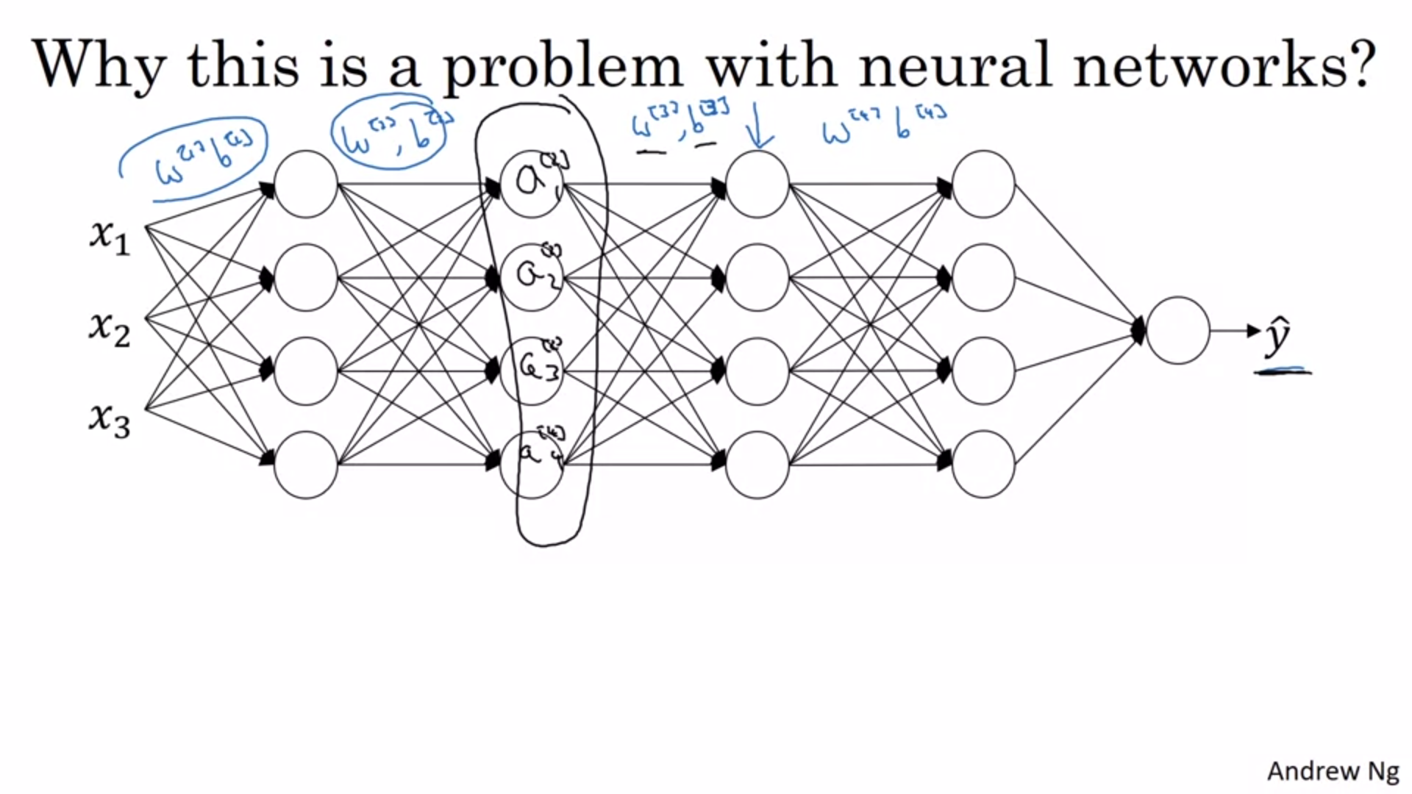

From the perspective of the third layer it gets some activations from the second layer and has to map them to y_hat.

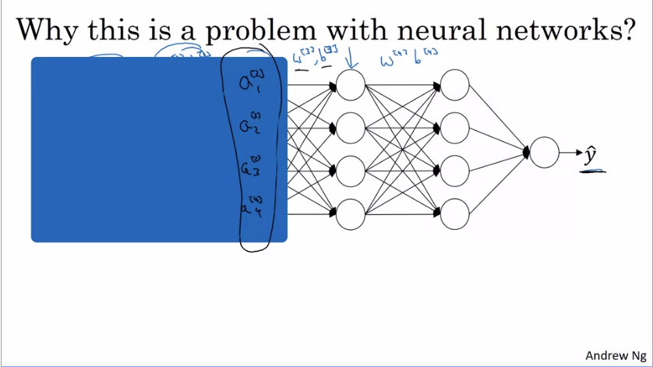

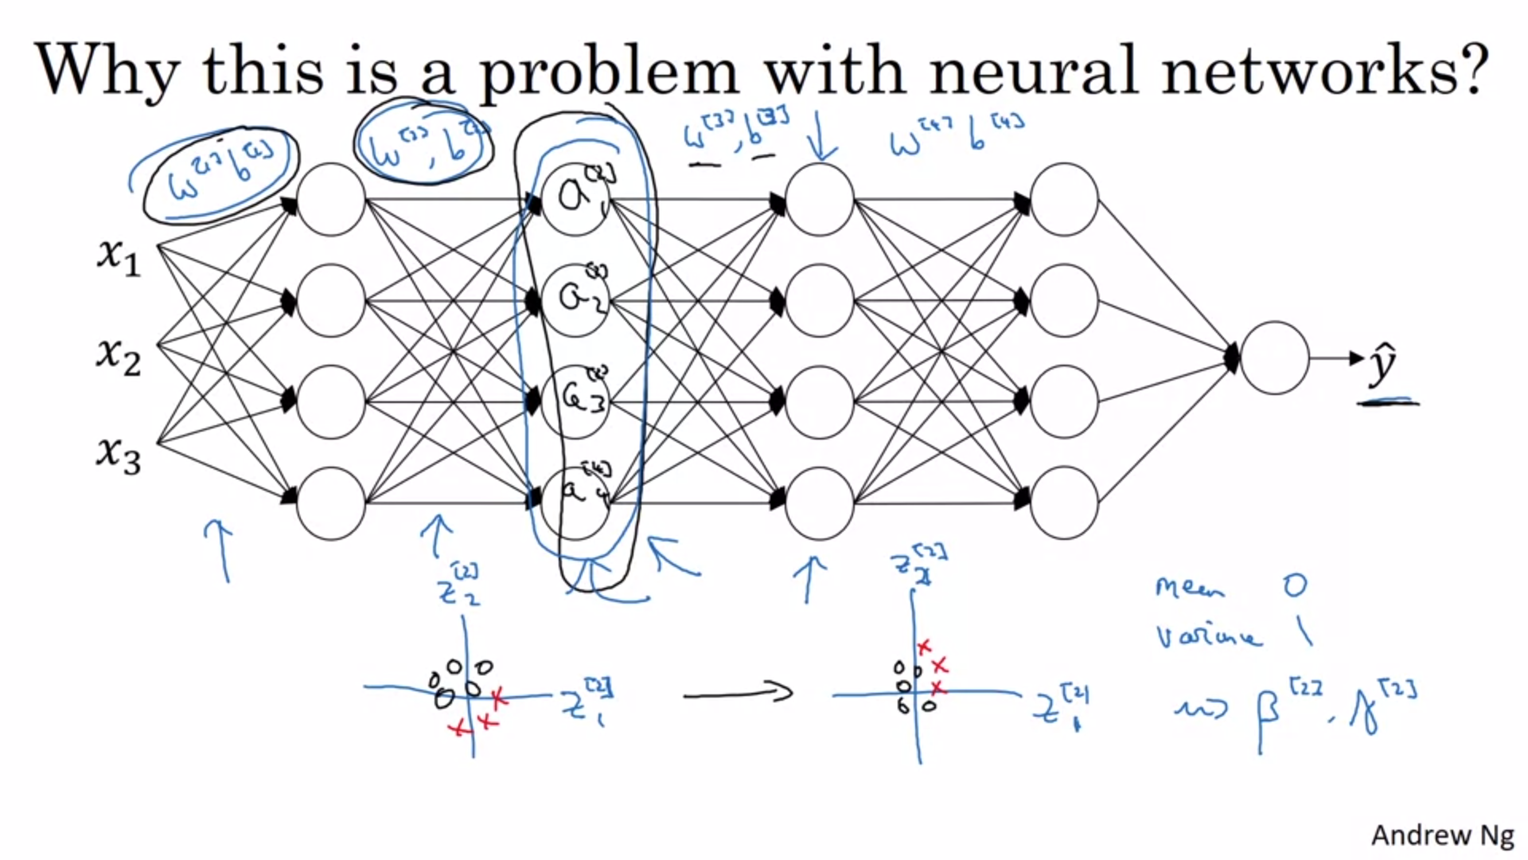

As the parameters of the first two layers change, the activations of the second layer also change. That means that the third layer suffers from covariate shift. Batch norm reduces the amount that the distribution of these hidden values shift around (as a result of changes in input layers). It ensures that no matter how the parameters of the earlier layers change, the mean and variance of z[1] and z[2] will stay the same. The mean and variance will be governed by beta and gamma. Like that the third layer has “more firm ground to stand on”.

This creates a decoupling of earlier layers. The layers can learn a bit more independently.

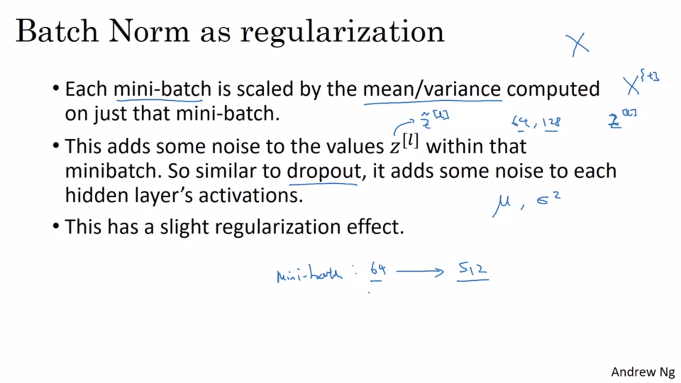

Multiplicative noise like dropout: scaling by standard deviation.

Additive noise: reducing mean.

This is not a huge regularization effect.

By using a bigger mini-batch size you reduce the regularization effect.

Don’t turn to batch norm for regularization!! Use it as way to normalize and speed up learning. Regularization is an unintended side effect.



At test time you might only have a single example and not a complete minibatch to compute the mean and standard deviation on.

So what do we need to do?

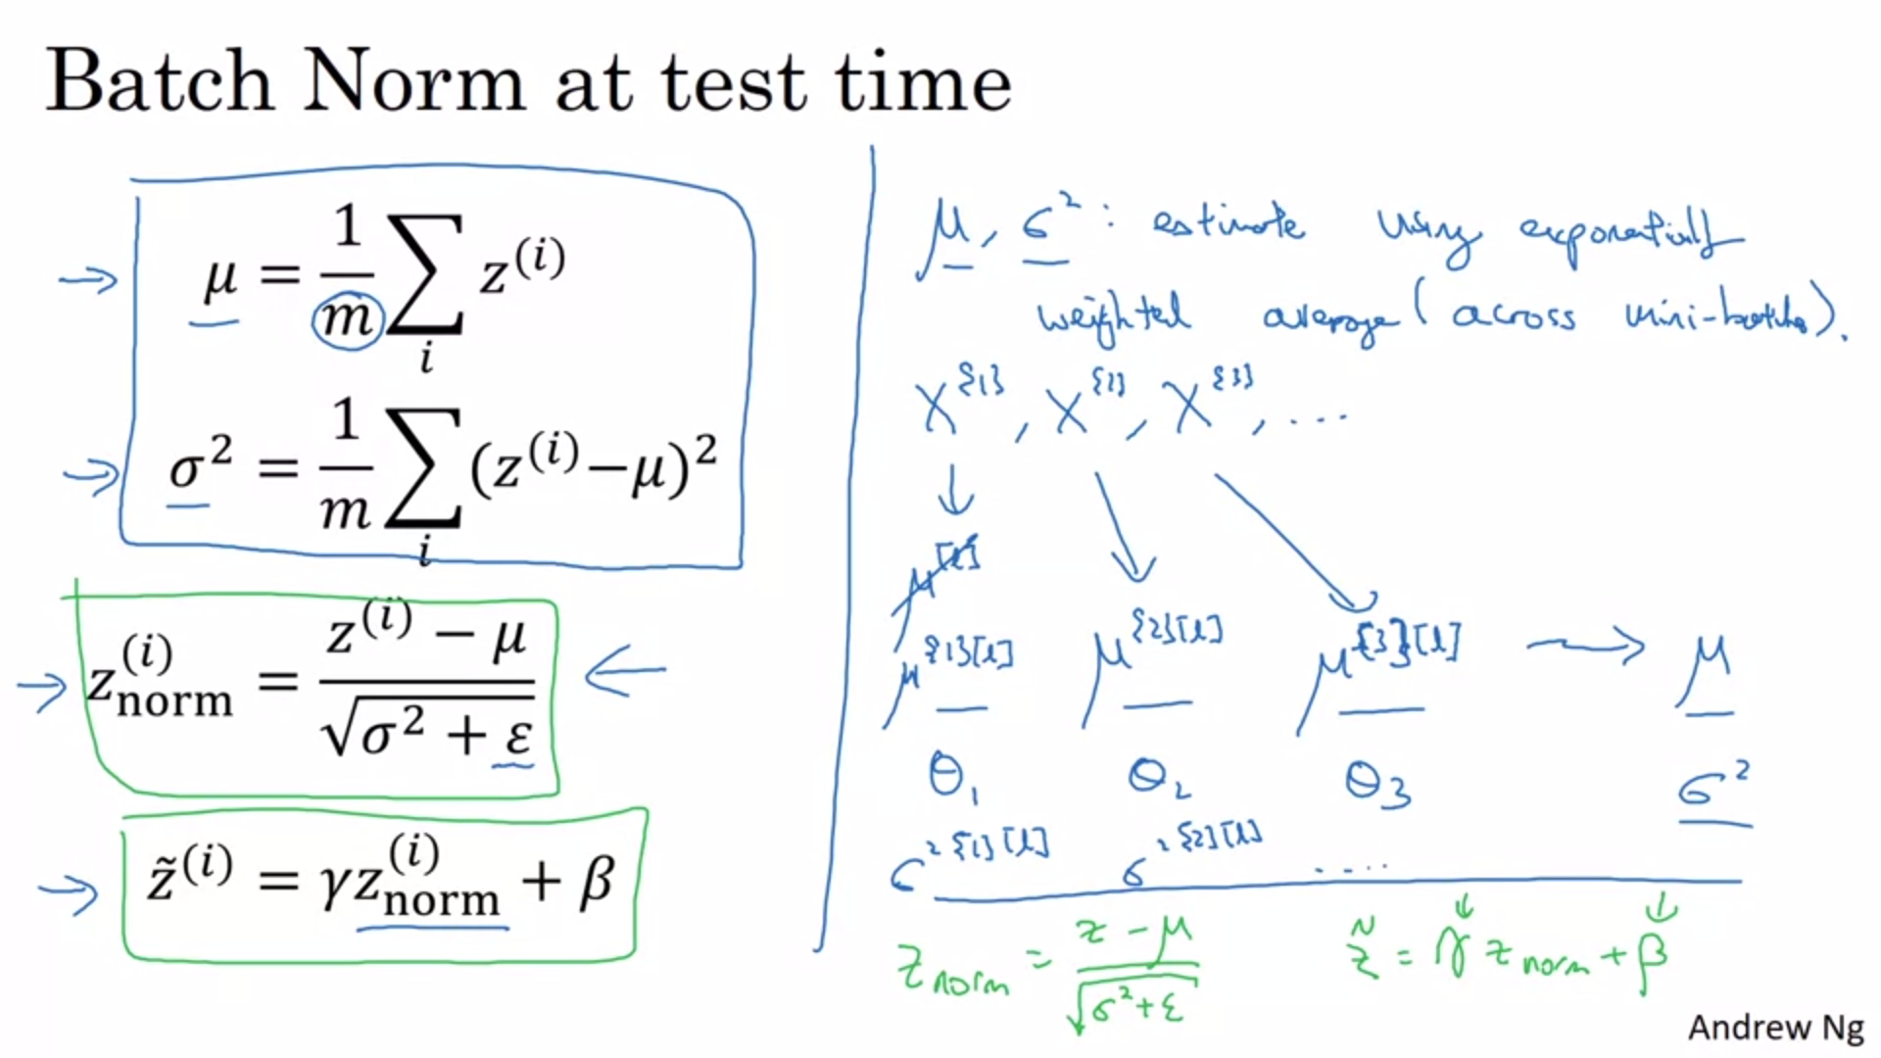

On the left side are the equations that we used during training.

Mu and sigma^2 are computed on the minibatch during training.

During test time it does not make sense to calculate mu and sigma^2 on an individual example.

We will estimate it using an exponentially weighted average across the minibatches.

The green formula is used during test time. Mu and sigma^2 are thus taken as exponentially weighted averages across the training set.

In practice this is pretty robust to which mu and sigma^2 you use. So other reasonable estimates should also work.